# A. GENERAL INFORMATION

## System Overview

FIBRAL is an image processing tool which runs parallel to MATLAB to determine fibre orientation within soft tissue structures. By offering an easy to use and user-friendly interface, FIBRAL can be applied without the prerequisite of previous MATLAB programming knowledge.

FIBRAL is capable of performing the following operations:

* Image acquisition using the built-in windows folder and file manager
* Colour space alteration and segmentation
* Image filtering to remove noise after segmentation
* Detection of fibre orientation
* Displaying results in the form of a histogram and both a linear and polar plot
* Calculation of overall “directionality coefficient” to provide single point metric of alignment

## System Requirements

As a direct result of utilising built-in MATLAB toolboxes, the only existing requirements are that of MATLAB version R2018a and above. At the time of writing this document, 28/11/2022, the minimum requirements to run MATLAB are:

* Windows 7 or above
* Any Intel or AMD processor with four logical cores
* 22GB of storage space
* 4GB RAM
* Image Analysis Toolbox

# B. USER INTERFACE

## 2.1 An Introduction to the FIBRAL User Interface

FIBRAL offers users a simple to use interface, with minimised user inputs to give users an efficient semi-autonomous system. An example of the blank user interface experienced upon opening, and the user interface showing results of a processed image are shown on the following two pages.

FIBRAL is capable of reading .png, .tif, .jpg and .bmp image files. However, further data formats can be included as and when required.

|  |  |
| --- | --- |
| Number | Function |
| 1 | Displays the selected image |
| 2 | Allows user to skip segmentation steps if wanting to rerun a previously segmented image |
| 3 | Allows user to select image for analysis using standard OS file browser |
| 4 | User copies file path for data saving here |
| 5 | This button is used to confirm the chosen file path |
| 6 | Begins image analysis sequence |
| 7 | Displays segmented image |
| 8 | Displays alignment index |
| 9 | Displays polar plot |
| 10 | Displays histogram and linear plot |

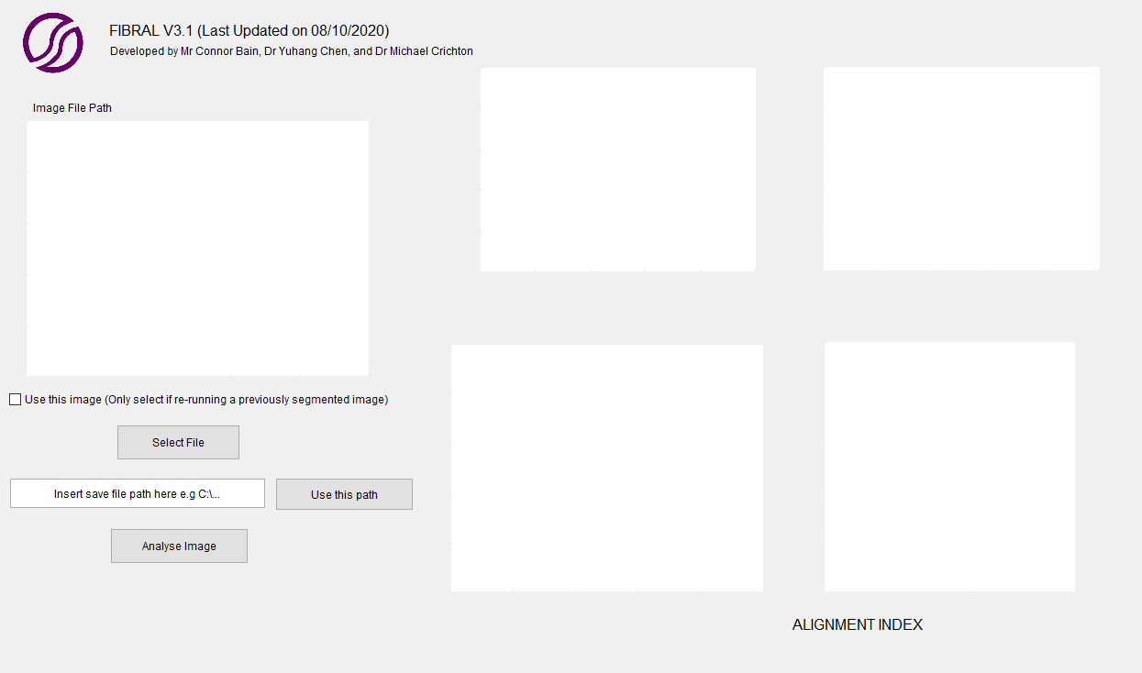

(1)

(2)

(3)

(4)

(5)

(6)

(7)

(8)

(9)

(10)

*Figure 1 – User interface after successful completion of tissue analysis*

# C. DEMONSTRATION OF CODE

## 3.1 Example 1 – Unwounded Tissue – BW Image

The following example will demonstrate how FIBRAL can be used to analyse fibrous tissue, without the requirement of image segmentation and filtering. This is useful when analysing a black and white image, or when wanting to rerun a previously processed image.

1. To open FIBRAL double click the GUI2.m file from your file explorer:

1. Once opened you should be presented with the following code window:

1. To run FIBRAL, click the green “run” arrow

1. You should now be presented with a blank FIBRAL GUI

1. To open the image for analysis, click the button labelled ‘Select File’



1. Navigate to the folder where the example images are saved and select the file ‘Example1.png’

The following should now be shown on the user interface

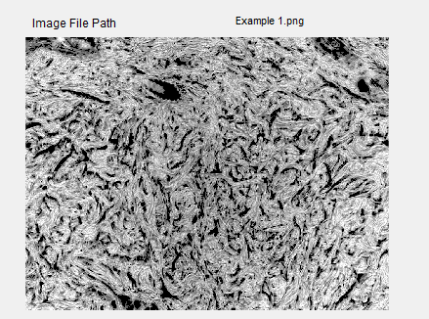

1. Tick the checkbox under the displayed image



1. Paste a save path into the dialog box and press the “use this path” button

1. Select the button labelled ‘Analyse Image’. You should now be presented with the following screen:

The following graphs should now be displayed on the interface. It can be noted from these graphs, that the no major angle of orientation is found. This is best represented with the polar plot and alignment index value which presents a value of 0.062. The code saves the following files into the chosen directory:

The “Intensities” and “Polar” image files contain the pixel data obtained from the 2D FFT and subsequent polar coordinate conversion algorithms. The histogram, linear plot and polar plot is saved as a .png file. The “Intensity Values” .txt file contains the intensity data at each 5 degree bin, allowing for recreation of the aforementioned plots in the user’s preferred data analysis software. The “Alignment Index” .txt stores the overall alignment coefficient calculated during analysis.

## 3.2 Example 2 – PSR Stained Wounded Tissue

The following example will demonstrate how FIBRAL can be used to analyse histological slides, such as those used for wound healing monitoring

1. Run FIBRAL and click the button labelled ‘Select File’



1. Navigate to the folder ‘FIBRAL/Images’ and select the file ‘Example2.png’

In the case of example 2, the image is not a png. In this instance you need to change the drop down menu (highlighted above in red) from “.png” to “All Files”.

The following should now be shown on the user interface

1. Paste a save path into the dialog box and press the “use this path” button

1. Now press the “Analyse Image” button. Doing so should present you with the following screen:

This image presents a primary angle of orientation (around 160±10⁰ from the horizontal). This is reflected in the alignment index value of 0.602; significantly higher than that seen in the previous example.

When analysing a colour image, two extra images are saved:

The file named “a_channel” shows the colour segmented image containing the a-channel superimposed with the +ve region of the b-channel (described in the methodology). The file named “a_channel_enhanced” shows the final image used for analysis after colour and contrast adjustments have been made, with subsequent island size removal algorithms run.

## 3.3 Explanation of Results Obtained During FIBRAL Analysis

During analysis, FIBRAL records and export a variety of parameters which are used to understand the overall global distribution of fibres in an image. Firstly, a linear plot and histogram is generated similar to that shown below:

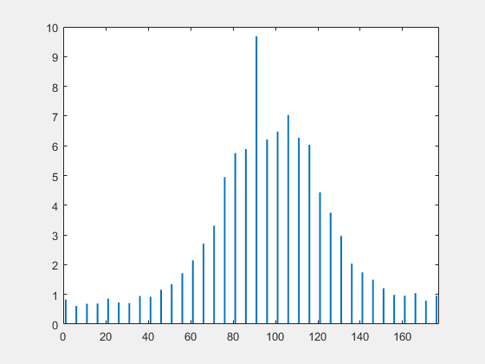

In the case of the linear plot, the x-axis denotes the angular orientation of fibres where 0 degrees denotes the horizontal plane, with 90 degrees denoting the vertical plane. The histogram presents similar data however the results are translated by 90 degrees where 0 degrees denotes the vertical plane. The y-axis in both plots is linked to the overall pixel intensity at each angle of distribution. Data here is obtained from the polar conversion of the adapted image. A continuous curve is displayed in the linear plot with the histogram outlining data summed in 5 degree bin sizes and normalised to a value between 0 and 10. In both cases, it is apparent that we observe a primary distribution of fibres along the horizontal plane with a deviation of approximately ±15 degrees.

To better visualise the distribution of these fibres, FIBRAL exports the linear plot data in the form of a polar plot.

Polar plots are used to provide better visualisation of the fibre distributions in an image. It should be noted that in all plots, the intensity value obtained is related to the overall pixel intensity at each integer angle; not a quantification of the number of fibres in an image. Hence, the absolute intensity values of various images may different due to variations in contrast and brightness, but the overall distribution characteristics remain consistent. To combine results among data sets for further analysis, it is advised that the user utilises a basic scaling algorithm to set all data sets to the same threshold value. Note, using a normalisation algorithm is not advised as this will greatly skew the data in cases where a non-linear distribution is observed. The intensity plot values are saved to a .txt file to allow the user to recreate the polar and linear plots using their preferred data presentation software.

The primary metric used to identify the level of alignment observed in an image is known as the “alignment index”. This value is calculated in FIBRAL and exported into a .txt file. To generate a quantifiable metric which describes the level of anisotropy present in a collagen fibre matrix a two-dimensional array is created which stores the overall intensity value at each one-degree bin size:

Where and relate to the angle and intensity values at each 1 degree bin size. To analyse the directionality of the fibre distribution, we create a direction vector at each 1 degree bin size with a magnitude equivalent to the summed intensity value of the pixels:

From this, a comparative analysis can be conducted whereby the dot product is calculated using ach permutation of two vectors:

Therefore, it is apparent that parallel vectors would provide a dot product of 1, with orthogonal vectors presenting a dot product value of -1. After completion of the above phase, all results are normalised such that they lie between 0 and 1. All segments can then be averaged to give an overall directionality quotient:

 A directionality quotient of 1 represents an ideally linear case, where all fibres are oriented along one angle. Whereas a directionality quotient of 0 represents ideal isotropy where an equal proportion of fibres are oriented across all angles.